Biopsychology
Exam I

Name

In some of the sections below, you have a choice of questions to answer. When the instructions say
“Please answer ANY TWO of the following THREE questions” or “Please answer ANY FOUR of the following SIX questions” please do only that. If you answer more than the required number, I will grade the answered questions in that section in order up to the requested number of answers, and will not grade additional questions beyond that.

Section I
Genetics and Evolution (1 point each)

- When mitosis occurs, both daughter cells end up with:
The answer is: both daughter cells end up with a full complement of chromosomes

- both daughter cells end up with a full complement of chromosomes
- both daughter cells end up with half the full complement of chromosomes
- a gamete is produced
- the sex of the individual is determined
- molecules pass through the blood brain barrier
- more than of the above

- Briefly define a "dichotomous" trait.

The answer is
Refers to traits with only a few possible phenotypes that fall into discrete classes; phenotype is controlled by one or only a few genes such as tall or short.
__________________________________________________________________________________
__________________________________________________________________________________

- Provide a brief definition of the term "gene".

The answer is:-
A gene is a basic physical and functional unit of heredity. Genes are made up of DNA. Some genes act as instructions to make molecules called proteins. However, many genes do not code for proteins
__________________________________________________________________________________
__________________________________________________________________________________

- Provide brief definitions of the terms "phenotype" and “genotype”.

The answer is;
Phenotype - refers to the observable physical properties of an organism; these include the organism's appearance, development, and behavior. While
Genotype - refers to an individual's collection of genes.
__________________________________________________________________________________

- According to Darwin, "fitness" is
The answer is:
The ability for an organism to contribute its genes to the gene pool of the next generation?
- the amount of time one spends at "curves"
- the ability of an organism to survive
- eating only fruits and vegetables forever
- the ability for an organism to contribute its genes to the gene pool of the next generation?

- Pinel feels one cannot easily establish which proportion of a behavior is caused by genes (nature) and which is caused by environment (nurture) and thus that the nature/nurture argument is flawed. Briefly explain this.
The answer is:
Nature refers to all the genes and the hereditary factors that influences who we are from our physical appearance to our personality characteristics while Nurture refers to all the environmental variables that impact who we are, inclusive with our early childhood experiences, how we were raised, our social relationships, and our surrounding culture.
__________________________________________________________________________________
__________________________________________________________________________________

Please answer ANY TWO of the following THREE questions. (1 points each)

- Who was Charles Darwin? When did he live? What was his occupation? What was his contribution to the field of evolution?
Charles Darwin was an English naturalist, geologist and biologist whom was known for his contributions to science evolution. He lived in down house England. Charles Darwin discussed his ideas with several naturalists, he needed time for extensive research and his geological work had priority. Where his letters contributed in the field of evolution.
__________________________________________________________________________________

- T or F: "Individuals evolve"? Explain.
__________________________________________________________________________________
__________________________________________________________________________________
__________________________________________________________________________________
__________________________________________________________________________________

- Briefly, explain why we bother to talk about evolution in a Biopsychology Course.
Biopsychology typically focuses on the immediate causes of behavior based in the physiology of a human or other animal, evolutionary psychology seeks to study the ultimate biological causes of behavior.
__________________________________________________________________________________

Please answer ANY TWO of the following THREE questions. (1 points each)

- Briefly describe the relationship between chromosomes, DNA, and genes.
The answer is:
Genes are segments of deoxyribonucleic acid (DNA) that contain the code for a specific protein that functions in one or more types of cells in the body. Chromosomes are structures within cells that contain a person's genes. Genes are contained in chromosomes, which are in the cell nucleus.
__________________________________________________________________________________
- Briefly compare Meiosis and Mitosis (be sure to include in your answer the function of each type of cell division)
The answer is:
Mitosis produces two diploid (2n) somatic cells that are genetically identical to each other and the original parent cell, whereas meiosis produces four haploid (n) gametes that are genetically unique from each other and the original parent (germ) cell.
__________________________________________________________________________________

- Briefly explain why we should care about genes in a biopsychology course?
__________________________________________________________________________________
__________________________________________________________________________________
__________________________________________________________________________________
__________________________________________________________________________________

Functional Anatomy of the Nervous System

Match the following (1 point each)
The answer is
Conducting region of neuron located between the soma and terminal --------------- axon
Separates the inside of the cell from the outside environment ----------------- cell membrane
Fatty insulation ----------------------------- myelin
Specialized connection site between neurons ------------------------ synapse

Answer the following questions (1 point each):

- Circle the structures that comprise the brain stem:

The answer is:
Medulla, midbrain, pons.

- What is meant by "functional organization" of the brain (i.e., localization of function)?
The answer is:
The sensory and motor functions of the human brain are well localized, but more complex functions such as speech and writing remain obscure. Injuries to the brain provide clues to how such systems are organized.
__________________________________________________________________________________

- Briefly define afferent and efferent as it relates to information flow in the nervous system.
The answer is:
Afferent nerve fibers refer to axonal projections that arrive at a particular brain region, as opposed to efferent projections that exit the region

Consider the following diagram and fill in the name of the boxes representing the different areas of the nervous system (use the names listed below the flow chart, 1 point each):

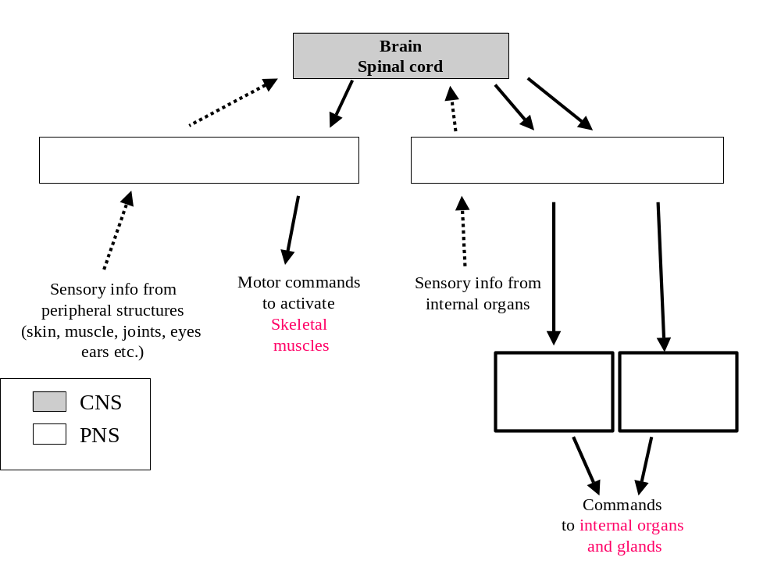
- match the labels below with the appropriate boxes in the diagram above (1 point each)
- Somatic division of PNS
- Autonomic division PNS
- Sympathetic branch
- Parasympathetic branch

The Neuron
Please label each external structure of the neuron. (1 point each)

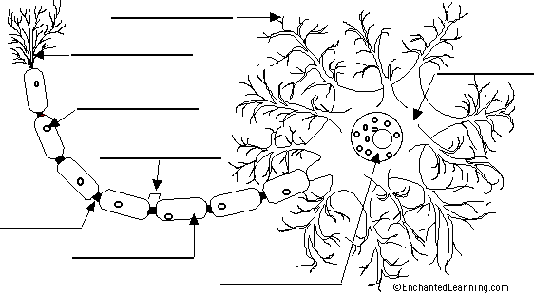

List and provide a description of the function of at least five major internal structures of a neuron
(2 points).
The answer is:

Cell body
Also known as a soma, the cell body is the neuron’s core. The cell body carries genetic information, maintains the neuron’s structure, and provides energy to drive activities.
Like other cell bodies, a neuron’s soma contains a nucleus and specialized organelles. It’s enclosed by a membrane which both protects it and allows it to interact with its immediate surroundings.
Axon
An axon is a long, tail-like structure which joins the cell body at a specialized junction called the axon hillock. Many axons are insulated with a fatty substance called myelin. Myelin helps axons to conduct an electrical signal. Neurons generally have one main axon.
Dendrites
Dendrites are fibrous roots that branch out from the cell body. Like antennae, dendrites receive and process signals from the axons of other neurons. Neurons can have more than one set of dendrites, known as dendritic trees.

Answer the following questions (1 point each):

- When a neuron is at rest, Sodium, potassium and calcium are ions that are higher in concentration on
the outside of neurons (compared with their intracellular concentration).
The answer is;
True.
True or False (circle one)

- What is the difference between an IPSP and an EPSP.
The answer is:

An EPSP is received when an excitatory presynaptic cell, connected to the dendrite, fires an action potential while an inhibitory postsynaptic potentials (IPSP) is a temporary hyperpolarization of postsynaptic membrane caused by the flow of negatively charged ions into the postsynaptic cell.

- _Sodium ion__ is the ion that is associated with the rising phase of the action potential and Potassium ion___ is associated with the falling phase of the action potential.

Below is a graph showing an action potential recorded from a typical neuron.

- Identify lines labeled A., B., and C on the graph below (2 points)
The answer is:
A – Action Potential B—Resting state C—Hyperpolarization

- Explain in detail the different phases and what is taking place during the phases. Make sure to explain what ions are present and how they change during each phase. (5 points).

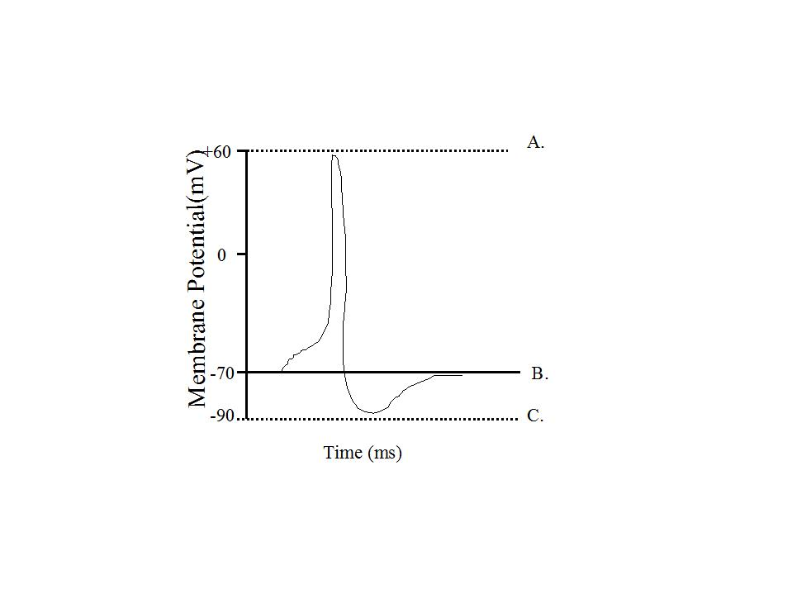
__________________________________________________________________________________
The answer is:
The action potential is a clear example of how changes in membrane potential can act as a signal. The depolarization, also called the rising phase, is caused when positively charged sodium ions (Na+) suddenly rush through open voltage-gated sodium channels into a neuron. As additional sodium rushes in, the membrane potential actually reverses its polarity. During this change of polarity, the membrane actually develops a positive value for a moment.
The repolarization or falling phase is caused by the slow closing of sodium channels and the opening of voltage-gated potassium channels. As a result, the membrane permeability to sodium declines to resting levels.
Hyperpolarization is a phase where some potassium channels remain open and sodium channels reset. A period of increased potassium permeability results in excessive potassium efflux before the potassium channels close. This results in hyperpolarization as seen in a slight dip following the spike.

The Eye
Please label each part of the eye. (1 point each)

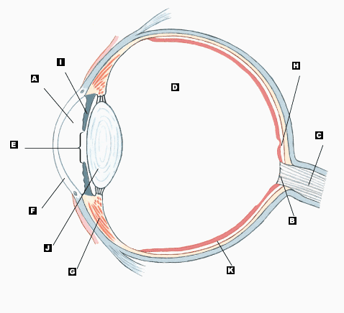

A. Cornea F. Comea
B. Macula G. Ciliary body and ciliary muscle
C. Optic Nerve H. Fovea
D. Vitreous body I. Iris
E. Pupil J. Lens
K. Retina

Please answer ANY FOUR of the following SIX questions. Make sure to answer the question and do not stray. Make sure to write in complete sentences and answer the questions directly.
(2 points each)

- What are the M and pathways in the brain?
The answer is:

The M pathway has high light/dark contrast detection, and is more sensitive at low spatial frequencies than high spatial frequencies. __________________________________________________________________________________

- Provide a short description of the two types of photoreceptors?
The answer is:
Two types of photoreceptors reside in the retina: cones and rods. The cones are responsible for daytime vision, while the rods respond under dark conditions. __________________________________________________________________________________

- Explain light and dark adaptation.
The answer is:
During light adaptation retinal sensitivity is lost. Dark adaptation is essentially the reverse of light adaptation. However, blackness is seen because our cones cease functioning in low intensity light. Also, all the rod pigments have been bleached out due to the bright light and the rods are initially nonfunctional.

- I mentioned reasons why information that falls on the fovea is seen more clearly. What is the fovea, and why is information that lands on this area seen most clearly?
__________________________________________________________________________________
__________________________________________________________________________________
__________________________________________________________________________________
__________________________________________________________________________________

- Explain neural convergence in the eye?

The answer is;
Convergence insufficiency is a condition in which your eyes are unable to work together when looking at nearby objects. This condition causes one eye to turn outward instead of inward with the other eye, creating double or blurred vision.

- Outline the major pathway for vision, tracing the information from the eye to the primary visual centers of the brain.
__________________________________________________________________________________
__________________________________________________________________________________
__________________________________________________________________________________
__________________________________________________________________________________

The Brain
Please label each part of the brain. (1 point each)

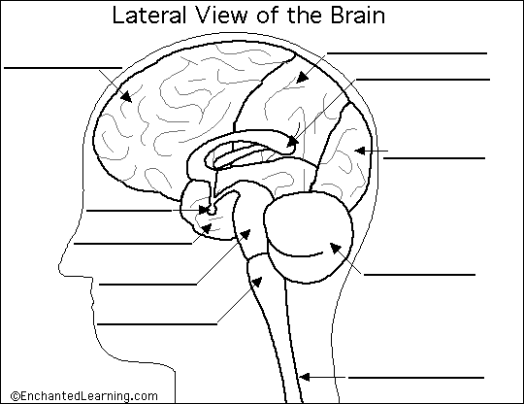

Please explain the roles of each of the structures you labeled. (5 points)
Cerebrum: is the largest part of the brain and is composed of right and left hemispheres. It performs higher functions like interpreting touch, vision and hearing, as well as speech, reasoning, emotions, learning, and fine control of movement.
Cerebellum: is located under the cerebrum. Its function is to coordinate muscle movements, maintain posture, and balance.
Brainstem: acts as a relay center connecting the cerebrum and cerebellum to the spinal cord. It performs many automatic functions such as breathing, heart rate, body temperature, wake and sleep cycles, digestion, sneezing, coughing, vomiting, and swallowing.
The meninges are three layers of tissue. The outermost layer, the dura mater, is thick and like leather. The second and third layers, the arachnoid and pia mater, are thin.
Cerebrospinal fluid is a watery fluid that flows in and around the four hollow spaces of the brain (called ventricles) and the spinal cord, and between two of the meninges. The ventricles are connected.

Section II
Multiple choice questions. (1 point each)

- The advantage of using laboratory animals instead of humans as subjects in biopsychological research is that
The answer is
there are fewer ethical restrictions on their study
- their brains are more simple.
- there are fewer ethical restrictions on their study.
- they are incapable of communication.
- all of the above
- both a and b

- The major problem in interpreting case studies has to do with their
The answer is correlations.

- generalizability.
- ethics.
- neurotoxic effects.
- correlations.
- purity.

- Using two or more different research approaches to make a scientific discovery that could not have been made using a single approach alone is called
The answer is:
converging operations.

- scientific inference.
- converging operations.
- scientific lordosis.
- confounding operations.
- none of the above

- In humans, all of the visual receptors are in the
The answer is
middle layer of the retina

- last layer of the retina to be reached by light entering the eye.
- first layer of the retina to be reached by light entering the eye.
- cornea.
- middle layer of the retina.
- optic disk.

- Humans without rods experience
The answer is
color blindness
- night blindness.
- color blindness.
- day blindness.
- both a and b.
- both b and c.

- The principle that precedence should be given to the most simple interpretation of a behavior when more than one interpretation is possible is called
The answer is:
Delgado's canon.

- the principle of precedence.
- the principle of simplicity.
- Delgado's canon.
- the principle of convergence.
- Morgan's canon.

- The reason why radioactive 2-DG is useful for revealing the level of activity of neurons in different parts of the brain is that 2-DG
The answer is:
Is absorbed by neurons in relation to their level of activity.
- is absorbed by neurons in relation to their level of activity.
- is metabolized by neurons in relation to their level of activity.
- is not metabolized by neurons.
- both a and c.
- both a and b.

- The relay station for information flowing into and out of the higher brain centers is the:
The answer is:
hypothalamus

- hippocampus
- hypothalamus
- reticular formation
- thalamus

- A ceiling effect occurs when a measure is too
The answer is
sensitive
- easy
- difficult
- variable
- sensitive

- Which of the following best describes way information on the fovea is seen most clearly.
The answer is
it hits the fovea before hitting the vitreous humor
- it does not pass through as many layers in the retina.
- it hits the fovea before hitting the vitreous humor.
- it gets processed faster in the occipital lobe.
- there is less data reduction.
- both a and d.

- If you were startled by a loud noise, there would be an increase in your skin's conductance of electricity. This response is called
The answer is
a skin conductance response.

- a skin conductance response.
- an EKG.
- a skin conductance level.
- an average evoked potential.
- a P300 wave.

- The P300
The answer is
is a component of the potential evoked by a meaningless click.

- is a negative EEG wave.
- is a far-field potential occurring 300 mm from the electrode.
- occurs about 300 seconds prior to a response.
- is a component of the potential evoked by a meaningless click.
- is an EEG wave that often occurs after the presentation of a momentary stimulus meaningful to the subject.

- The digit-span test is the most commonly used test of
The answer is:
counting.

- short-term memory.
- counting.
- arithmetic.
- intelligence.
- lateralization.

- According to the cognitive neuroscientific approach
The answer is
each complex cognitive process is composed of a number of simple processes.

- each complex cognitive process is composed of a number of simple processes.
- each simple cognitive process is mediated by an area of the brain
- using a subtractive image approach areas that control simple processes can be identified
- none of the above.
- all of the above.

- In humans, the primary visual cortex is in the _______ lobe.
The answer is
occipital

- frontal
- parietal
- occipital
- temporal
- optic disk

- One major advantage of a using event related potentials as a measure in psychological research is that:
The answer is:
subjects are required to provide more descriptive commentary

- no overt response is required by the subject
- brain waves never lie
- subjects are required to provide more descriptive commentary
- all of the above are advantages
- there are no advantages to this method

- Within the limbic system the structure thought to play a major role in memories is?
The answer is
none of the above.

- the septum
- the paricturalis
- the thalamus
- the hippocampus
- none of the above.

- Light passes through layers of the retina in which of the following sequences?
The answer is:
None of the above
- receptor layer, bipolar cell layer, retinal ganglion cell layer
- retinal ganglion cell layer, horizontal cell layer, receptor layer
- retinal ganglion cell layer, amacrine cell layer, receptor layer
- both b and c.
- none of the above.

- High-acuity, color vision is mediated by only the small foveal area of the retina. Nevertheless, we have perceptions of the world that are expansive in both their color and their detail. This is possible because
The answer is:
of retinal disparity.

- of the optic disks.
- of retinal disparity.
- of the difference between the photopic and scotopic spectral sensitivity curves.
- we have depth perception.
- our visual systems integrate the foveal images from several different visual fixations to produce the subjective visual perception that we are experiencing at any instant.

- Transduction refers to the
The answer is
translation of one form of energy to another
- perception of lights.
- disappearance of visual stimuli.
- transmission of sensory signals to the cortex.
- transmission of visual signals to the cortex.
- translation of one form of energy to another.

- The bleaching of rhodopsin
The answer is
depolarizes rods.

- depolarizes rods.
- depolarizes cones.
- opens Na+ channels.
- both a and c.
- hyperpolarizes rods.

- The retina-geniculate-striate system is organized
- from top to bottom.
- from left to right.
- on the basis of wavelength.
- retinotopically.
- both a and b.

- The pituitary gland is attached to which brain structure?
The answer is
hypothalamus

- cerebellum
- medulla
- thalamus
- hypothalamus

- The brain structure that controls heart rate, breathing, and blood pressure is the:
The answer is
medulla

- reticular formation
- thalamus
- cerebellum
- medulla

- Your car speedometer fluctuates between 15 and 60 miles per hour as you are driving on the freeway at a constant speed. As a measure of speed, your speedometer is low in:
The answer is
reactivity

- reliability
- validity
- reactivity
- all of the above

Section III
Essay/Short answer

Please answer ANY FOUR of the following SIX questions. Make sure to answer the question and do not stray. Make sure to write in complete sentences and answer the questions directly.
(2 points each)

- What are advantages to the blood-brain barrier? What are disadvantages to the blood-brain barrier?
Advantages
Protects the brain from "foreign substances" in the blood that may injure the brain. Protects the brain from hormones and neurotransmitters in the rest of the body. Maintains a constant environment for the brain.
Disadvantages
The blood–brain barrier is generally very effective at preventing unwanted substances from accessing the brain, which has a downside. The vast majority of potential drug treatments do not readily cross the barrier, posing a huge impediment to treating mental and neurological disorders.

- Provide a description of neurotransmitters; what are they, what do they do, how do they work? Next, tell me at least two different neurotransmitters that are important for Biopsychologists.
__________________________________________________________________________________
__________________________________________________________________________________
__________________________________________________________________________________
__________________________________________________________________________________
__________________________________________________________________________________

- Provide a description of at least 5 ways that drugs can alter synaptic transmission.
The answer is;
One way to affect synaptic transmission is to increase the amount of neurotransmitter released into the synaptic space. Drugs like alcohol, heroin, and nicotine indirectly excite the dopamine-containing neurons in the ventral tegmental area (VTA) so that they produce more action potentials.
Nicotine not only acts at the cell body in the VTA to increase the number of action potentials and number of vesicles released from a neuron, but it also acts by another mechanism to alter dopamine release. When nicotine binds to nicotine receptors on the dopamine-containing axon terminals in the nucleus accumbency, more dopamine is released with each action potential.
Drugs may also alter synaptic transmission by directly affecting the postsynaptic receptors. Some drugs activate receptors, and others block them.
A third way to affect synaptic transmission is to alter the removal of neurotransmitters from the synapse. Cocaine and amphetamines work this way (this is the second way amphetamines can alter neurotransmission).
Alcohol affects the brain’s neurons in several ways. It alters their membranes and ion channels, enzymes, and receptors, and it also binds directly to the receptors for acetylcholine, serotonin, and GABA and the NMDA receptors for glutamate.

- Is it true that we only use 10 percent of our brain? If so, what does that mean? If not, why not?
__________________________________________________________________________________
__________________________________________________________________________________
__________________________________________________________________________________
__________________________________________________________________________________

- Please explain the similarities and differences between MRI and fMRI. Next, explain two different techniques for imaging the human brain.
Similarities
An MRI or fMRI is a painless, non-invasive medical procedure. An MRI machine looks like a large donut. Its circular shape houses a powerful magnet. The patient is positioned in the center opening of the machine for the scan.
An MRI exam is noisy, with loud and repetitive thumping and tapping sounds. However, patients are offered special headphones that contain no metal to help block the sound. Young children and people who are claustrophobic may require a sedative so they can remain calm and still during the scan.
Fast, efficient and highly detailed, MRIs and fMRIs are very valuable diagnostic tools that can help your doctor accurately assess and effectively treat a wide range of medical conditions.
Differences
Magnetic resonance imaging (MRI) is a type of medical imaging that uses strong magnetic fields to produce images of organs in the body. Unlike other types of imaging such as CT (or CAT) scans or PET scans, an MRI does not use X-rays.
MRIs are used to detect or assess a variety of conditions in many parts of the body. For example, an MRI of the brain and spinal cord can reveal evidence of: while Functional magnetic resonance imaging (fMRI) is a specialized form of MRI that is used to examine the brain’s functional anatomy, meaning which part of the brain is handling critical functions. An fMRI measures small changes in blood flow that occur over time with brain activity.
The scan can help doctors assess the effects of a stroke or other condition affecting the brain or spinal cord. It is also used to detect structural abnormalities that cannot be detected with other imaging techniques. The information from an fMRI helps a doctor determine the most effective treatment or assess how well a chosen treatment is working.

- What does the myelin sheath of the axon accomplish? Why type of axon is more likely to be myelinated, and why?

The answer is
The myelin sheath is a protective covering that surrounds fibres called axons, the long thin projections that extend from the main body of a nerve cell or neuron. However, the main function of myelin is to protect and insulate these axons and enhance their transmission of electrical impulses.
Why axon is more likely to be myelinated
Myelinated axons are ensheathed along their entire length. The axon caliber (diameter) in mammalian PNS ranges from 0.1 μm to 20 μm, with unmyelinated axons being less than 2 μm and myelinated axons being more than 1–2 μm in diameter. In the CNS, almost all axons with diameters greater than 0.2 μm are myelinated.

